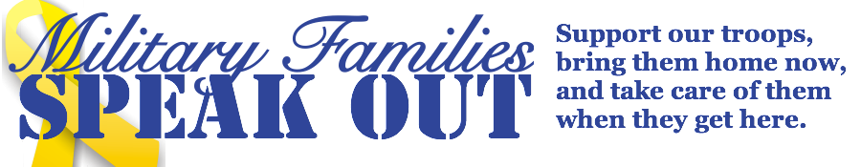
Summer, 2017

MFSO Demands:
NO TROOP INCREASE IN AFGHANISTAN!
By Paula Rogovin, MFSO Steering
Committee, MFSO NJ
“Obama set a cap a year ago of 8,400 troops in Afghanistan… Nevertheless, there are at least another 2,000 US troops in Afghanistan not included in the official count. These include forces that are technically considered temporary even if they have been in the war zone for months.” (Guardian, June 15, 2017)
Now, the Trump administration is considering sending 3000-5000 additional troops to Afghanistan!
MFSO says:
NO TROOP INCREASE IN AFGHANISTAN! BRING ALL TROOPS HOME FROM AFGHANISTAN NOW!
TAKE CARE OF OUR TROOPS WHEN THEY GET HOME!
The Steering Committee of MFSO calls on members and friends to immediately work with others to:
- Work with other groups to plan a demonstration to be held the day after (or soon after) the Trump Administration announces another troop level increase in Afghanistan. Check the MFSO website (www.MFSO.com) or Facebook Page (Military Families Speak Out), Veterans For Peace (www.veteransforpeace.org) , as well as United for Peace and Justice (www.unitedforpeace.org) Feel free to use the calls in CA and NJ to help you prepare for your demonstration.
- Contact members of Congress to say NO troop increases in Afghanistan. National Priorities Project provides phone # and e-mail addresses for members of Congress, and it has lots of information about the costs of the wars. https://www.nationalpriorities.org/take-action/contact-your-representative/

JOIN
VETERANS FOR PEACE, Chapter 110
In a demonstration against another troop level
increase in Afghanistan.
4:00 p.m. the day after the Trump Administration makes the announcement

PCH and Main St. in Huntington Beach by Congressman Dana Rohrabacher’s office
Bring a sign
Please join veterans, military families and other peace groups that are opposed to the increase of troop levels in Afghanistan. Each new sitting president has increased troop levels and it’s time to
“END THESE ESCALATIONS”
Join Veterans, Military Families, and other residents the Wednesday of-or-after the announcement of increase in troop levels in Afghanistan.
Teaneck Peace Vigil
National Guard Armory
Teaneck Road and Liberty Road, Teaneck, NJ
4-5 pm
No Troop Increase!
Bring all troops home from Afghanistan!
MFSO, Bergen County, VFP, Chapter 21 NJ

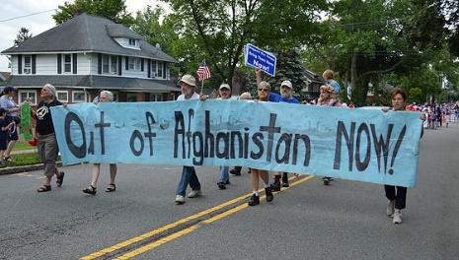
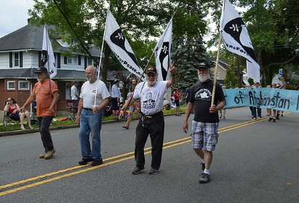
MFSO, Bergen County, VFP, Chapter 21 NJ and friends in the Peace Contingent of Teaneck’s 4th of July parade, 2017
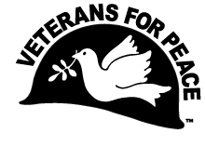
MFSO members and friends will be a presence at the Veterans For Peace Annual Convention in Chicago, IL at the Palmer House from Aug 9-13. Please join us there. The theme of this year’s convention will be:
Education Not Militarization
On Sunday, Veterans For Peace will March for "Education Not Militarization! Support Children, Youth, Community", mustering at 11:30. Wrap up with the amazing Jackson Browne, who has generously offered to host a concert to benefit Veterans For Peace.
Go to www.VeteransForPeace.org for details.

CAREER EDUCATION TRAVEL

Military Families Speak Out
An Interactive workshop
THE VET, THEIR FAMILY
AND
THE TRUTH ABOUT JOINING THE MILITARY
FRI. Aug 11, 9:00am – 10:30am
6th floor Millennium Parlor
at the VFP Convention
PTSD TBI PROSTHESIS

MFSO mixer
Friday, August 11. 5 pm
MFSO Hospitality Suite,
at the VFP Convention
Meet MFSO Steering Committee members and other military families. Free drinks and food. Contact Pat Alviso (565-579-3980) or Tim Kahlor (951-216-9620)

Please sign this Petition: No Attacks on Syria – Stop Endless War
Keep up the Pressure: No Attacks on Syria –
Stop Endless War!
The devastating war in Syria rages on. We must step up our efforts to stop our government from expanding its war in Syria and to stop Endless War.
The Syria Petition created by United for Peace & Justice is directed to Congress. MFSO is co-sponsoring this important Petition along with these additional outstanding organizations:
AFSC Peace and Economic Security Program
Catholic Conference of Superiors of Men Religious
Code Pink
Out of Syria-Boston
People Demanding Action
Veterans for Peace
US Peace Council
Western States Legal Foundation
September 11th Families for Peaceful Tomorrows
Please read and sign the Petition:
Sign the Petition today, No Attacks on Syria – Stop Endless War calling on Congress to:
- Recognize that there is no military solution to terrorism; stop widening the conflict in Syria and instead try to end it.
- End all bombing missions and aerial strikes; bring home U.S. troops and special operations teams; stop supplying arms and revoke the 2001 AUMF.
- Increase humanitarian aid and help resettle more Syrian refugees in the United States.
- Abide by international laws, treaties, diplomatic norms, and our Constitution.
- Reverse current escalations of military action and instead work to de-escalate and demilitarize conflicts around the world.
The unimaginable brutality of the war in Syria must end. This war, as with all other wars, kills, injures, poisons the water and land, creates refugees and crushes the hopes and dreams of millions of people.

“This Madness Must Cease”. (MLK)

More War For Iraq and Afghanistan’s
Oil and Minerals?
WE SAY NO!
IRAQ: Trump said, “Keep the oil. For the victor belongs the spoils.” (CNN) http://www.cnn.com/videos/politics/2017/01/23/donald-trump-iraq-oil-isis-starr-lwe-tsr.cnn
AFGHANISTAN: “Trump Finds Reason for the U.S. to Remain in Afghanistan: Minerals” (New York Times)
“President Trump, searching for a reason to keep the United States in Afghanistan after 16 years of war, has latched on to a prospect that tantalized previous administrations: Afghanistan’s vast mineral wealth, which his advisers and Afghan officials have told him could be profitably extracted by Western companies.
Mr. Trump has discussed the country’s mineral deposits with President Ashraf Ghani, who promoted mining as an economic opportunity in one of their first conversations.” Read more: https://www.nytimes.com/2017/07/25/world/asia/afghanistan-trump-mineral-deposits.html
Military Families Speak Out reaffirms our opposition to military involvement in Iraq and Afghanistan. We say – It’s not our oil! They’re not our minerals. Support Our Troops. Bring Them Home NOW! Take Care of Them When They Get Here! We call on all military families to join this effort! By Paula Rogovin, MFSO Bergen County, NJ

JOIN MFSO!
If you have a loved one serving in the military, please join MFSO.
For more information: Contact Pat Alviso at mfso@mfso.org. Find MFSO at www.mfso.org or at Military Families Speak Out on Facebook.
Call: 565-579-3980
Donations are welcome.

A MESSAGE FOR ACTIVE DUTY SERVICE MEMBERS AND VETERANS from
ABOUT FACE: VETERANS AGAINST THE WAR

About Face 2017 National Convention: Veterans Organizing at the Intersections of Militarism

Join us for our 2017 National Convention in Stony Point, NY September 1st-4th with an opening event in Brooklyn, NY Thursday, August 31st. Continuing the legacy of our organization, founded in 2004, this is the first convention since deciding to change the name of the organization from Iraq Veterans Against the War to About Face: Veterans Against the War. This year is especially exciting as we roll out our new brand we also begin a new era of outreach and organizing at the intersections of US Militarism.

Join us for workshops and plenaries on work with our allies, our place as veterans in movements for social change. We will develop our campaign to Drop the MIC (military industrial complex), and our work to stand against the rise of right-wing bigotry in our Vets Vs Hate work. In addition to digging into these and other important issues we will also spend time strengthening our community through building healing spaces, taking time in nature, and sharing delicious and healthy meals together.
http://www.ivaw.org/about-face-2017-national-convention-veterans-organizing-intersections-militarism

Troops vs Military Contractors in Afghanistan
U.S. Troops Contractors
2016: 9,142 16,055
2017: not available 26,022
In 2016 approximately 72% of total DOD employees were contractors. Sources: “Boots on the Ground,” monthly report to Congress. DENTCOM Quarterly Contractor Census.

There is even less accountability for contractors than for the U.S. military. This is troublesome.

Stay Involved!
Military Family Members, please work with groups in your community to protest U.S. military involvement in Iraq, Afghanistan, and Syria.
Participate on one of the vigils listed below.
- Check with United For Peace and Justice to see if other actions are planned in your community or region. www.unitedforpeace.org
- Work with other groups in your community to plan
- Community forums or teach-ins
- Meetings with your Senators or Representatives in Congress
- Vigils or demonstrations
- Actions at a Federal Office, a National Guard Armory, a war memorial, a busy corner, or other high traffic area in your community
Send a press advisory, then call the press so you can spread the word.
Ongoing vigils:
Long Beach, Orange County, CA: EVERY Friday. 7-9
pm. 2nd and Nieto in front of the Chase Bank in
Belmont Shore. MFSO with the Long Beach Area
Peace Network
Huntington Beach, CA: EVERY Sunday. 12 noon. at
the foot of the Huntington Beach Pier. ENOUGH
campaign.
Orange, CA: 3rd Thursday of every month. 5:30-7pm. Chapman and Glassell (in the Traffic Circle) in Orange. MFSO and Code Pink
Seal Beach, CA: Last Wednesday of the month. 5-
6:60 pm. in front of the globe at Leisure World.
Senior Patriots for Peace
Los Angeles, CA: EVERY Sunday. 6am-4pm. Just north of the Santa Monica Pier, under Bubba Gumps.
Arlington West
Huntington Beach CA: First Sundays. 7:30am to
3:30pm. 6th and PCH. Arlington West
Teaneck, NJ: EVERY Wednesday, 4-5 pm. National
Guard Armory. Corner of Teaneck Rd. and Liberty Rd.
in Teaneck. Teaneck Peace Vigil. MFSO, Bergen
County, Veterans For Peace, Chapter 21 NJ.
Leonia, NJ: EVERY Sunday, 4-4:30 pm. Broad Ave.
and Ft. Lee Rd. Leonia Peace Vigil Group.
Yellow Springs, OH: EVERY Saturday. corner of Xenia
Ave & Limestone.
Missouri – Kansas City: ‘Patriots for Peace’ Demonstrations. Weekly, Every Tuesday, 5-6 pm
63rd and Ward Parkway (Median Strip on South Corner) Kansas City, MO. Contact: schwartzkatz@sbcglobal.net
MFSO’s New Media Team
Do you want help writing a press advisory or release for your event? Would you like to share National MFSO releases with press in your community? Do you have a loved one who is currently active duty and deployed? Has your loved one died by suicide? Has your family suffered in other ways from the impact of the current wars? Would you be willing to speak to the press? Melissa and Tim would like to hear from you.
Melissa Castaneda
Press Releases
mfso.melissa@gmail.com

Tim Kahlor
Media Contact
tkahlor@outlook.com
951-216-9620
MORAL INJURY
Bill Scheurer, Executive Director of On Earth Peace, and member of the MFSO Steering Committee, has shared these two podcast episodes on moral injury and moral exploitation in war hoping that they will be helpful in our work. https://hiphination.org/episodes/episode-two-moral-exploitation-jan-31-2017/
- https://hiphination.org/episodes/episode-3-the-morality-of-war-feb-7th-2017/

www.icasualties.org.
Icasualties provides data about deaths (not including suicides) and injuries of U.S. service members in Iraq and Afghanistan. It’s another important tool for educating the public about the impact of the wars.

A Call for Your Writing!

Military Family members - We welcome poems, articles, and stories. Send to Paula Rogovin, MFSO newsletter editor. MFSO@mfso.org

